 |  | 

CONDITION BASED ASSESSMENT
QUICK SCANNING REPORT
SBUM DIAGNOSTIC JOHOR
TNB BAHAGIAN PEMBAHAGIAN JOHOR

FUNCTIONAL LOCATION (ERMS) | : | JJBU/PCE/J03951
FUNCTIONAL LOCATION (SITE) | : | JJBU/PCE/J03951
SUBSTATION NAME (ERMS) | : | SK KG MAJU JAYA
SUBSTATION NAME (SITE) | : | SEK. KEB. KG. MAJU JAYA
COORDINATE | : | 1.579787, 103.718929
SUBSTATION TYPE | : | PCE
AREA | : | JOHOR BAHRU
STATE | : | JOHOR
PO | : | 42234207
DATE | : | 14 JUL 2026
SCANNED BY
THERMOGRAPHY | : | MUHAMMAD OMAR RIDZUAN (2013MY20N010)
EQUIPMENT/TOOLS
THERMOGRAPHY | : | FLIR T640 (SN 55912229) (CALIBRATION DUE DATE: 26 DEC 2026)
PREPARED BY
NAME OF CONTRACTOR | : | EET ENGINEERING SERVICES SDN BHD
ADDRESS | : | NO.38, JALAN SS19/1D,
 | : | 47500, SUBANG JAYA, SELANGOR.
SUBSTATION SIGNBOARD
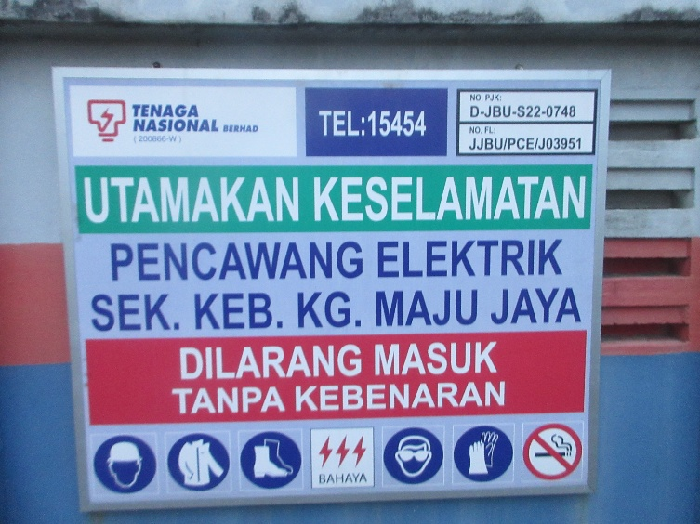

EXECUTIVE Summary
NO. | EQUIPMENT | DEFECT AREA | IR (Abs.T) | IR (∆T) | DEFECT
 | FP TX1 – INCOMING F1 | INCOMING LINK CONNECTION/  RED PHASE | 66.7 °C | 14.8 °C | REPAIR IMMEDIATELY
 | FP TX1 – OUTGOING F4 | OUTGOING FUSE CONNECTION/  RED PHASE | 106.2 °C | 61.2 °C | REPAIR IMMEDIATELY
 | FP TX1 – OUTGOING F6 | OUTGOING FUSE CONNECTION/  RED PHASE | 149.2 °C | 66.6 °C | REPAIR IMMEDIATELY
 | FP TX1 – OUTGOING F7 | OUTGOING FUSE CONNECTION/  RED PHASE | 219.2 °C | 167.6 °C | REPAIR IMMEDIATELY

visual defect Summary
NO. | EQUIPMENT | DEFECT DESCRIPTION | ELECTRICAL | NON-ELECTRICAL
1 | SUBSTATION | NO PADLOCK MAIN GATE |  | X
2 | LIGHTING | MISSING | X
3 | FIRE EXTINGUISHER | MISSING |  | X

 |  | Substation |  |  | SK KG MAJU JAYA |  |  |  |  |  |  |  |  |  |  |  |  | Date: 14/07/2026
 |  | Equipment |  |  | FP TX1 |  | Manufacturer |  |  |  |  |  |  |  |  | TOPRANK |  | Time: 07:40 PM
 |  | Model |  |  | J-SLOTTED |  | Rating |  |  |  |  |  |  |  |  | 1600A |  | Humidity: 63%
 |  | Area |  |  | OVERVIEW |  |  |  |  |  |  |  |  |  |  | Feeder No. |  | -
Feeder Name |  | -
 | IR IMAGE |  |  |  |  |  |  |  |  |  |  | VISUAL IMAGE
 | 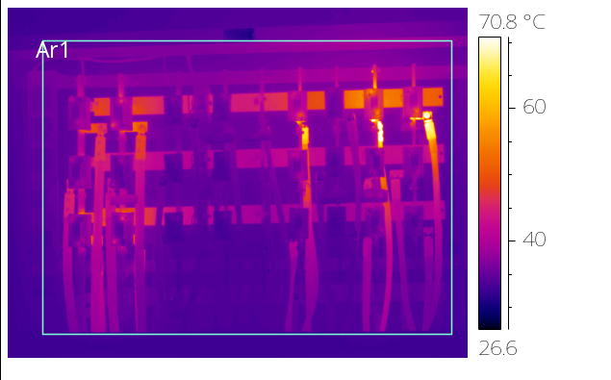 |  |  |  |  |  |  |  |  |  |  | 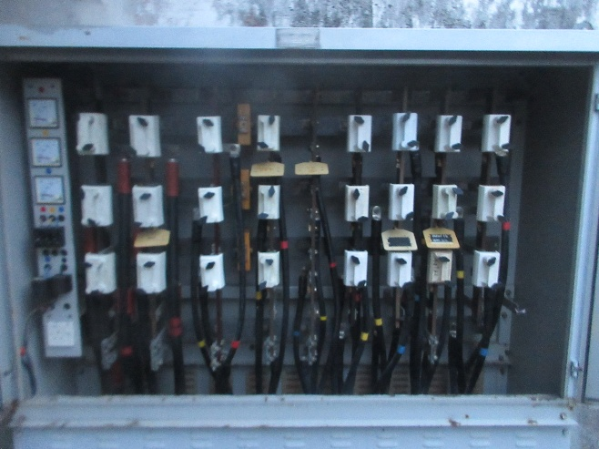
 | PARAMETER |  | VALUE
 | Spot Temp.1 (Sp1) |  | - |  |  |  |  |  |  |  |  |  |  |  | PARAMETER |  |  | VALUE
 | Spot Temp. 2 (Sp2) |  | - |  |  |  |  |  |  |  |  |  |  |  | Serial No. |  |  | 652
 | Average Temp. (Ar1) |  | 37.1 °C |  |  |  |  |  |  |  |  |  |  |  | Heater (A) |  |  | -
 | Ambient Temp. |  | 32.0 °C |  |  |  |  |  |  |  |  |  |  |  | CB Position |  |  | -
 | Delta T ( ∆ T) |  | - |  |  |  |  |  |  |  |  |  |  |  | Busbar Position |  |  | -
 | Load (A) |  | - |  |  |  |  |  |  |  |  |  |  |  | Cable Type |  |  | -
 | Severity |  | -
Analysis & Recommendations:
Analysis: Please refer the following page for details defect.
Recommendation: N/A

 |  | Substation |  |  | SK KG MAJU JAYA |  |  |  |  |  |  |  |  |  |  |  |  | Date: 14/07/2026
 |  | Equipment |  |  | FP TX1 |  | Manufacturer |  |  |  |  |  |  |  |  | TOPRANK |  | Time: 07:40 PM
 |  | Model |  |  | J-SLOTTED |  | Rating |  |  |  |  |  |  |  |  | 1600A |  | Humidity: 63%
 |  | Area |  |  | LINK CONNECTION |  |  |  |  |  |  |  |  |  |  | Feeder No. |  | INCOMING F1
Feeder Name |  | INCOMING F1 – RED PHASE
 | IR IMAGE |  |  |  |  |  |  |  |  |  |  | VISUAL IMAGE
 | 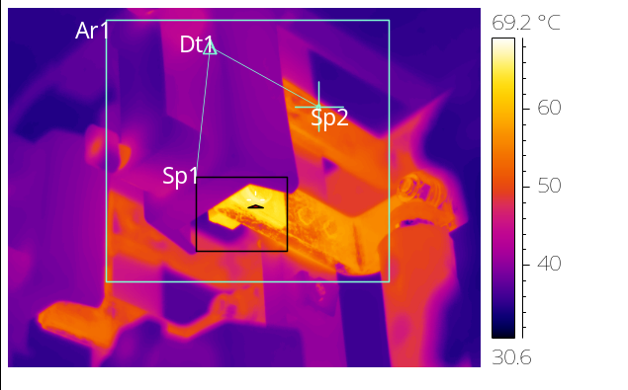 |  |  |  |  |  |  |  |  |  |  | 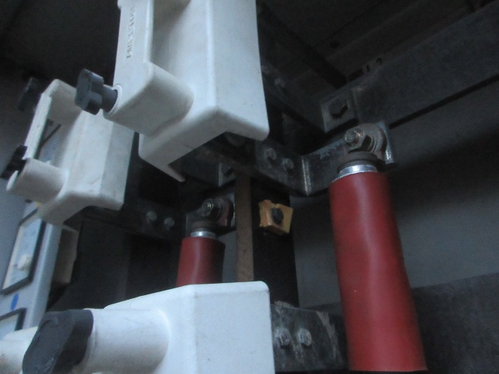
 | PARAMETER |  | VALUE
 | Spot Temp.1 (Sp1) |  | 66.7 °C |  |  |  |  |  |  |  |  |  |  |  | PARAMETER |  |  | VALUE
 | Spot Temp. 2 (Sp2) |  | 51.9 °C |  |  |  |  |  |  |  |  |  |  |  | Serial No. |  |  | 652
 | Average Temp. (Ar1) |  | 44.2 °C |  |  |  |  |  |  |  |  |  |  |  | Heater (A) |  |  | -
 | Ambient Temp. |  | 32.0 °C |  |  |  |  |  |  |  |  |  |  |  | CB Position |  |  | -
 | Delta T ( ∆ T) |  | 14.8 °C |  |  |  |  |  |  |  |  |  |  |  | Busbar Position |  |  | -
 | Load (A) |  | - |  |  |  |  |  |  |  |  |  |  |  | Cable Type |  |  | XLPE
 | Severity |  | REPAIR IMMEDIATELY
Analysis & Recommendations:
Analysis: Thermal image above indicates hot spot detected at INCOMING LINK CONNECTION. The anomaly is due to loosen or bad contact at the connection point.
Recommendation: To inspect, clean the contact surface and re-tighten the connection point. Replace defective parts if necessary.

 |  | Substation |  |  | SK KG MAJU JAYA |  |  |  |  |  |  |  |  |  |  |  |  | Date: 14/07/2026
 |  | Equipment |  |  | FP TX1 |  | Manufacturer |  |  |  |  |  |  |  |  | TOPRANK |  | Time: 07:40 PM
 |  | Model |  |  | J-SLOTTED |  | Rating |  |  |  |  |  |  |  |  | 1600A |  | Humidity: 63%
 |  | Area |  |  | FUSE CONNECTION |  |  |  |  |  |  |  |  |  |  | Feeder No. |  | OUTGOING F4
Feeder Name |  | OUTGOING F4 – RED PHASE
 | IR IMAGE |  |  |  |  |  |  |  |  |  |  | VISUAL IMAGE
 | 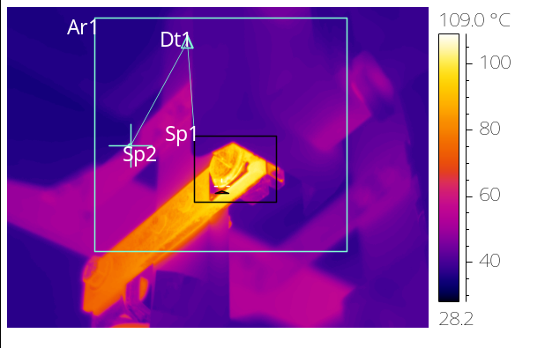 |  |  |  |  |  |  |  |  |  |  | 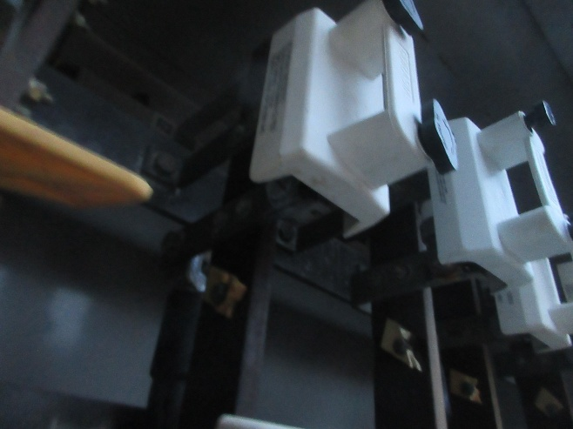
 | PARAMETER |  | VALUE
 | Spot Temp.1 (Sp1) |  | 106.2 °C |  |  |  |  |  |  |  |  |  |  |  | PARAMETER |  |  | VALUE
 | Spot Temp. 2 (Sp2) |  | 45.0 °C |  |  |  |  |  |  |  |  |  |  |  | Serial No. |  |  | 652
 | Average Temp. (Ar1) |  | 48.8 °C |  |  |  |  |  |  |  |  |  |  |  | Heater (A) |  |  | -
 | Ambient Temp. |  | 32.0 °C |  |  |  |  |  |  |  |  |  |  |  | CB Position |  |  | -
 | Delta T ( ∆ T) |  | 61.2 °C |  |  |  |  |  |  |  |  |  |  |  | Busbar Position |  |  | -
 | Load (A) |  | - |  |  |  |  |  |  |  |  |  |  |  | Cable Type |  |  | XLPE
 | Severity |  | REPAIR IMMEDIATELY
Analysis & Recommendations:
Analysis: Thermal image above indicates hot spot detected at OUTGOING FUSE CONNECTION. The anomaly is due to loosen or bad contact at the connection point.
Recommendation: To inspect, clean the contact surface and re-tighten the connection point. Replace defective parts if necessary.

 |  | Substation |  |  | SK KG MAJU JAYA |  |  |  |  |  |  |  |  |  |  |  |  | Date: 14/07/2026
 |  | Equipment |  |  | FP TX1 |  | Manufacturer |  |  |  |  |  |  |  |  | TOPRANK |  | Time: 07:40 PM
 |  | Model |  |  | J-SLOTTED |  | Rating |  |  |  |  |  |  |  |  | 1600A |  | Humidity: 63%
 |  | Area |  |  | FUSE CONNECTION |  |  |  |  |  |  |  |  |  |  | Feeder No. |  | OUTGOING F6
Feeder Name |  | OUTGOING F6 – RED PHASE
 | IR IMAGE |  |  |  |  |  |  |  |  |  |  | VISUAL IMAGE
 | 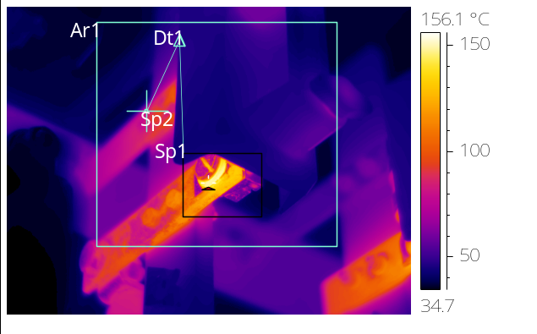 |  |  |  |  |  |  |  |  |  |  | 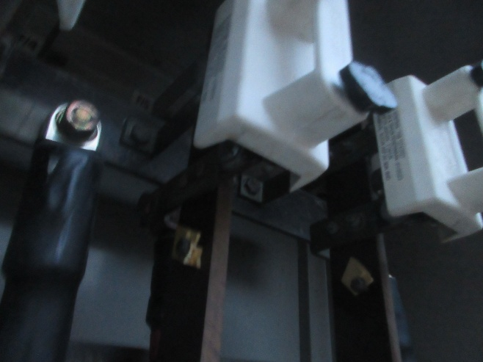
 | PARAMETER |  | VALUE
 | Spot Temp.1 (Sp1) |  | 149.2 °C |  |  |  |  |  |  |  |  |  |  |  | PARAMETER |  |  | VALUE
 | Spot Temp. 2 (Sp2) |  | 82.6 °C |  |  |  |  |  |  |  |  |  |  |  | Serial No. |  |  | 652
 | Average Temp. (Ar1) |  | 56.2 °C |  |  |  |  |  |  |  |  |  |  |  | Heater (A) |  |  | -
 | Ambient Temp. |  | 32.0 °C |  |  |  |  |  |  |  |  |  |  |  | CB Position |  |  | -
 | Delta T ( ∆ T) |  | 66.6 °C |  |  |  |  |  |  |  |  |  |  |  | Busbar Position |  |  | -
 | Load (A) |  | - |  |  |  |  |  |  |  |  |  |  |  | Cable Type |  |  | XLPE
 | Severity |  | REPAIR IMMEDIATELY
Analysis & Recommendations:
Analysis: Thermal image above indicates hot spot detected at OUTGOING FUSE CONNECTION. The anomaly is due to loosen or bad contact at the connection point.
Recommendation: To inspect, clean the contact surface and re-tighten the connection point. Replace defective parts if necessary.

 |  | Substation |  |  | SK KG MAJU JAYA |  |  |  |  |  |  |  |  |  |  |  |  | Date: 14/07/2026
 |  | Equipment |  |  | FP TX1 |  | Manufacturer |  |  |  |  |  |  |  |  | TOPRANK |  | Time: 07:40 PM
 |  | Model |  |  | J-SLOTTED |  | Rating |  |  |  |  |  |  |  |  | 1600A |  | Humidity: 63%
 |  | Area |  |  | FUSE CONNECTION |  |  |  |  |  |  |  |  |  |  | Feeder No. |  | OUTGOING F7
Feeder Name |  | OUTGOING F7 – RED PHASE
 | IR IMAGE |  |  |  |  |  |  |  |  |  |  | VISUAL IMAGE
 | 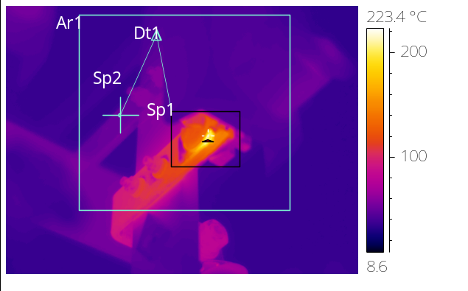 |  |  |  |  |  |  |  |  |  |  | 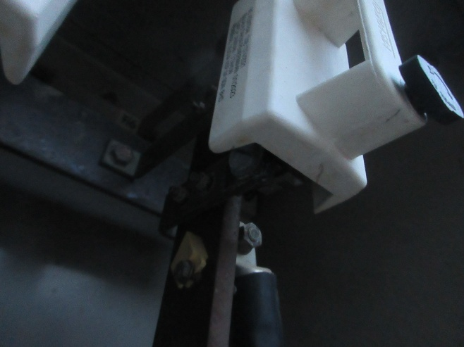
 | PARAMETER |  | VALUE
 | Spot Temp.1 (Sp1) |  | 219.2 °C |  |  |  |  |  |  |  |  |  |  |  | PARAMETER |  |  | VALUE
 | Spot Temp. 2 (Sp2) |  | *51.6 °C |  |  |  |  |  |  |  |  |  |  |  | Serial No. |  |  | 652
 | Average Temp. (Ar1) |  | *53.5 °C |  |  |  |  |  |  |  |  |  |  |  | Heater (A) |  |  | -
 | Ambient Temp. |  | 32.0 °C |  |  |  |  |  |  |  |  |  |  |  | CB Position |  |  | -
 | Delta T ( ∆ T) |  | *167.6 °C |  |  |  |  |  |  |  |  |  |  |  | Busbar Position |  |  | -
 | Load (A) |  | - |  |  |  |  |  |  |  |  |  |  |  | Cable Type |  |  | XLPE
 | Severity |  | REPAIR IMMEDIATELY
Analysis & Recommendations:
Analysis: Thermal image above indicates hot spot detected at OUTGOING FUSE CONNECTION. The anomaly is due to loosen or bad contact at the connection point.
Recommendation: To inspect, clean the contact surface and re-tighten the connection point. Replace defective parts if necessary.

SUBSTATION CONDITION

SUBSTATION OVERVIEW |  | SIGNBOARD
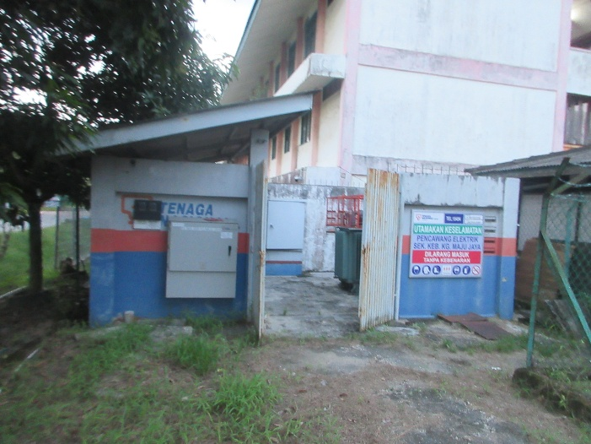 |  | 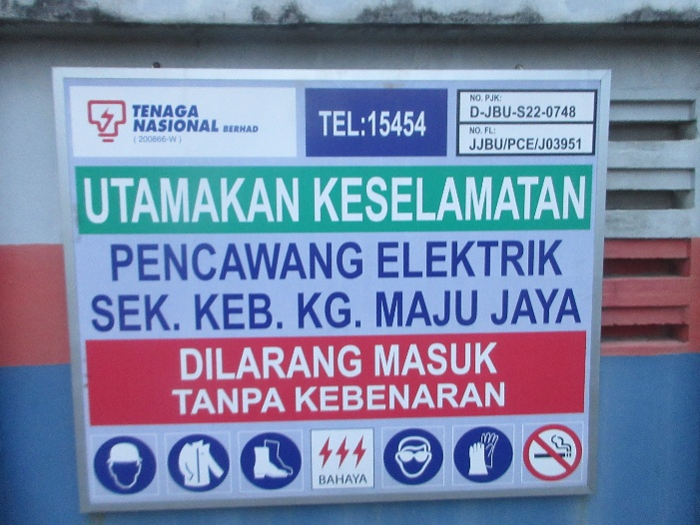
SWITCHGEAR |  | SWITCHGEAR NAMEPLATE
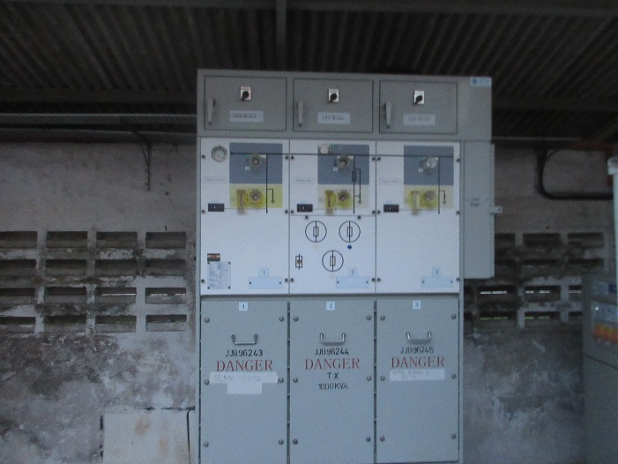 |  | 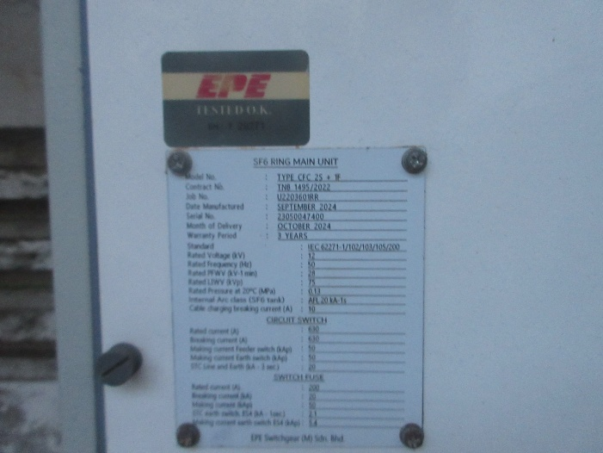
TRANSFORMER 1 |  | TRANSFORMER 1 NAMEPLATE
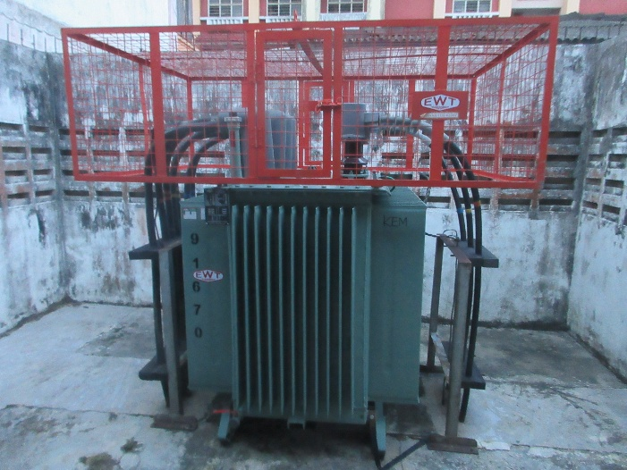 |  | 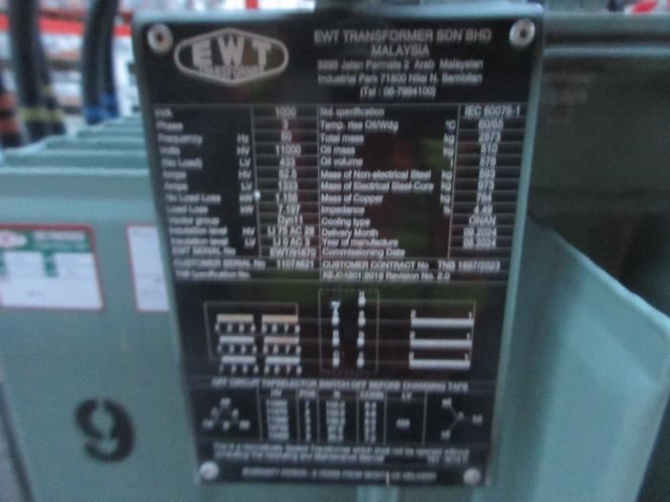

SUBSTATION CONDITION

TRANSFORMER 2 |  | TRANSFORMER 2 NAMEPLATE
N/A |  | N/A
FEEDER PILLAR TX1 |  | FEEDER PILLAR TX1 NAMEPLATE
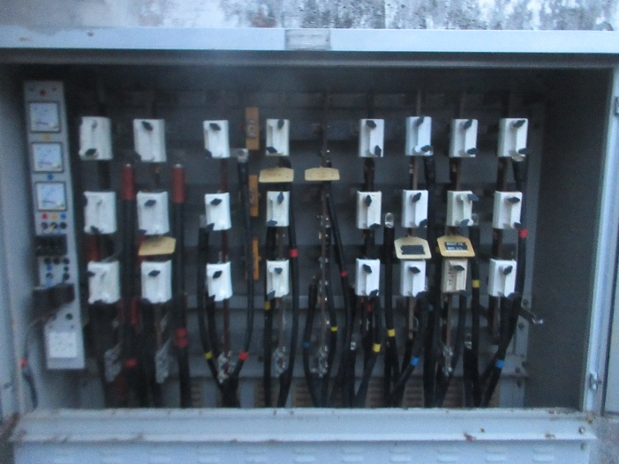 |  | 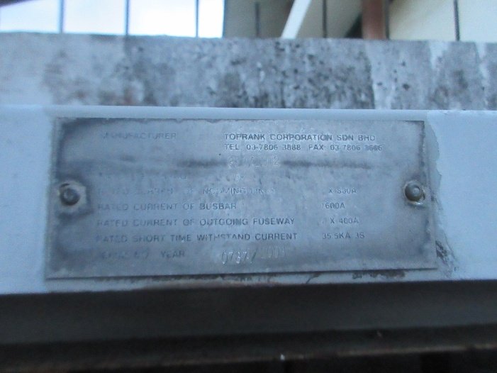
FEEDER PILLAR TX2 |  | FEEDER PILLAR TX2 NAMEPLATE
N/A |  | N/A
SUBSTATION CONDITION

EFI |  | SF6 INDICATOR
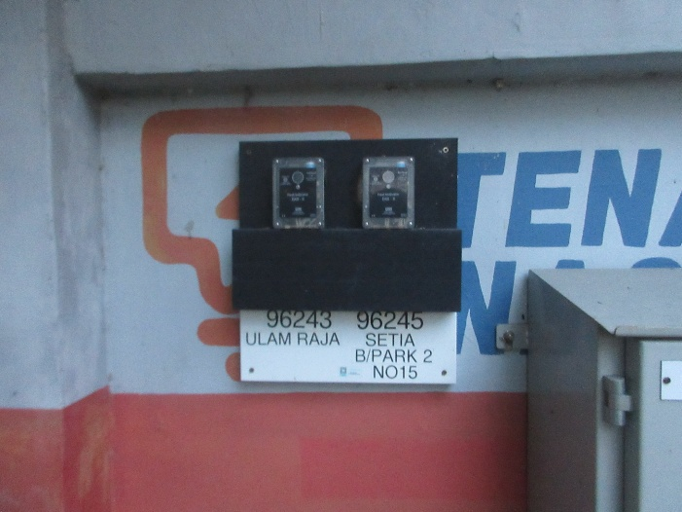 |  | 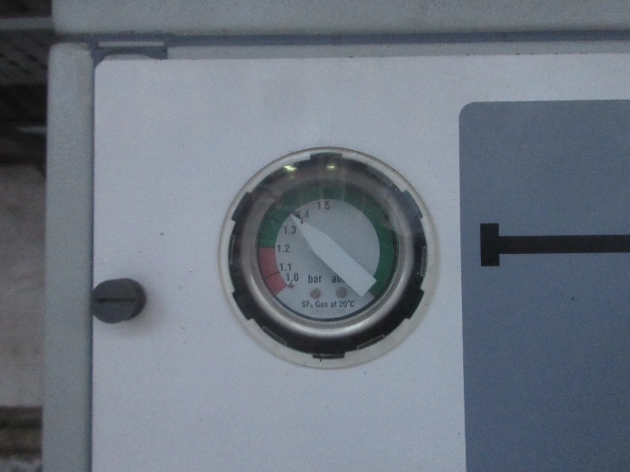
BATTERY |  | BATTERY NAMEPLATE
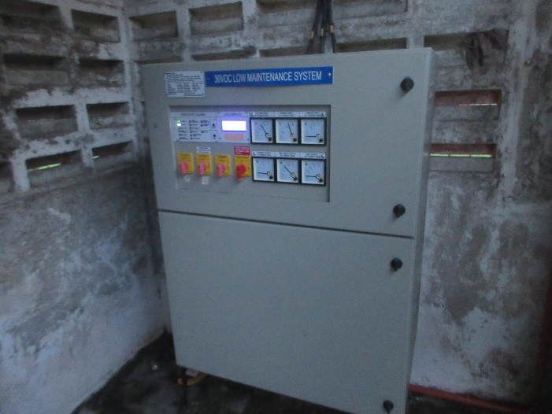 |  | 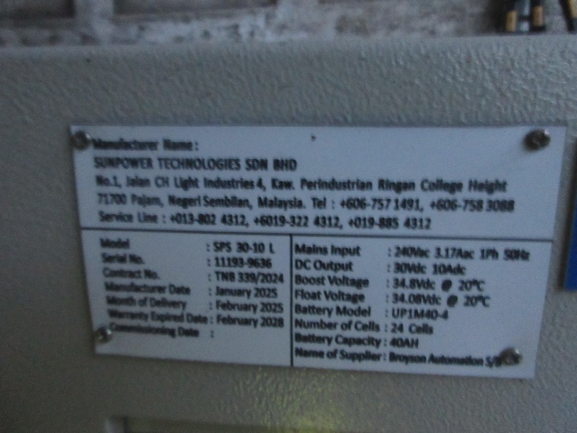
FIRE EXTINGUISHER |  | FIRE EXTINGUISHER NAMEPLATE
N/A |  | N/A

SUBSTATION CONDITION

SWITCHGEAR PANEL NAME |  | LAST PREVENTIVE MAINTENANCE
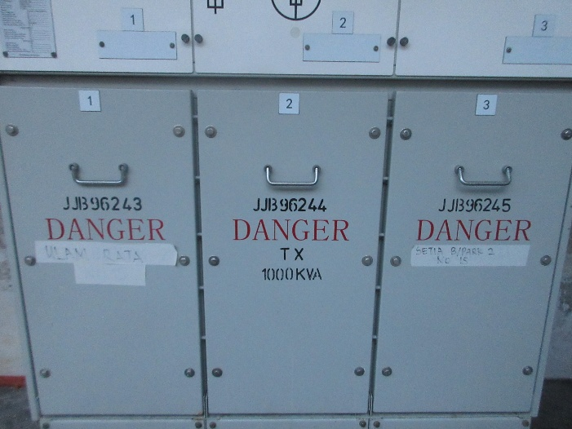 |  | 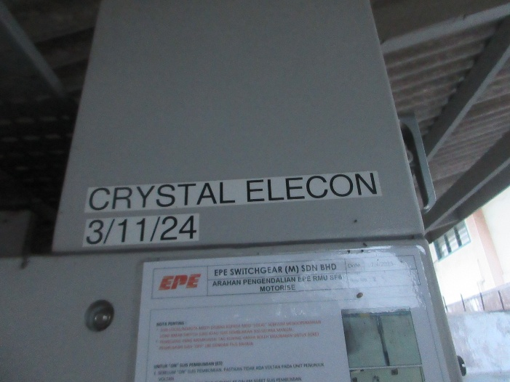

VISUAL DEFECT

SUBSTATION |  | LIGHTING
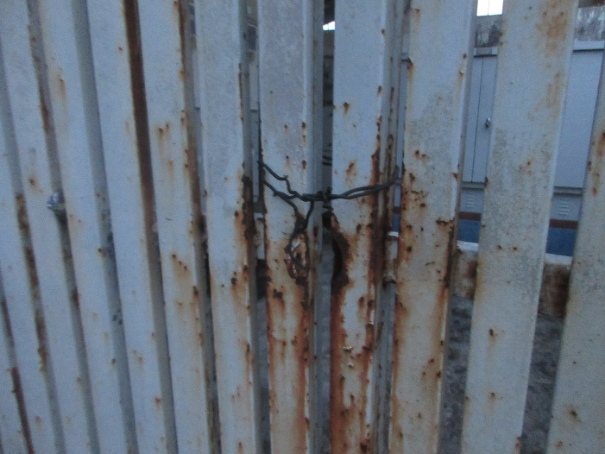 |  | 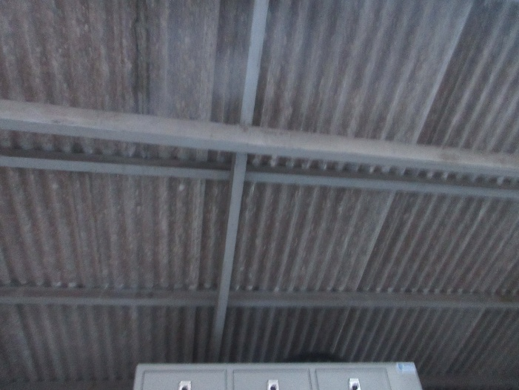
NO PADLOCK MAIN GATE |  | MISSING
FIRE EXTINGUISHER
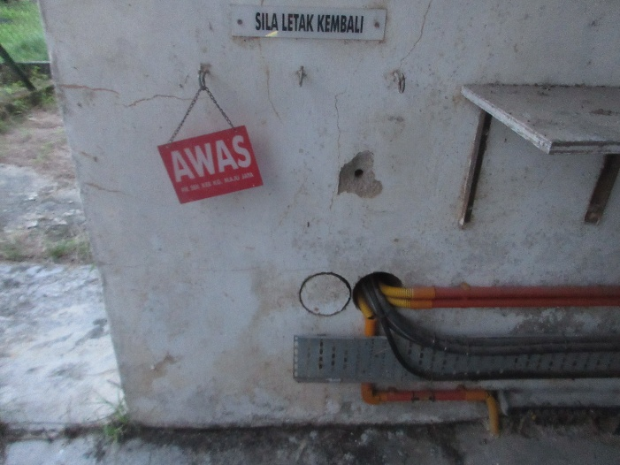
MISSING

NORMAL/DEFECT STICKER

NORMAL STICKER |  | DEFECT STICKER
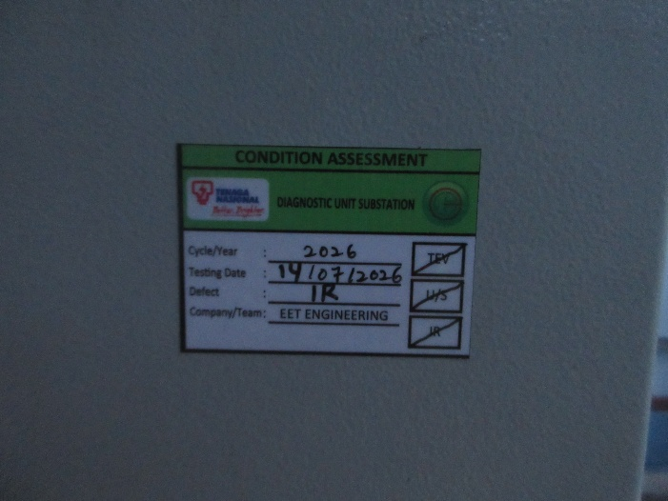 |  | 